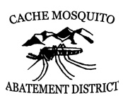
Cache Mosquito Abatement District
Board of Trustees

Business Meeting
Thursday, May 25, 2023 7:00 p.m.
Bear River Health Department
85 East 1800 North, North Logan

Agenda

- Adopt agenda
- Review and approve minutes of April 27, 2023 meeting
- Discuss insurance for drones
- Discuss roof brakes above the shop
- Manager report
- Administrative Manager report
- Review and approve bills
- Adjourn

